## References

* Webpage Template

<https://colorlib.com/wp/free-bootstrap-admin-dashboard-templates/>

<http://www.999webtemplates.com/gentelella-free-bootstrap-admin-template/>

* jQuery Sparkline
* <https://github.com/gwatts/jquery.sparkline>
* [http://omnipotent.net/jquery.sparkline/#s-about](http://omnipotent.net/jquery.sparkline/%23s-about)
* jQuery Flot
* <https://github.com/flot/flot>
* <http://www.flotcharts.org/>

## Requirements

* Azure Subscription
* Visual Studio

## Goals

* Customize a portal UI for
  + Presenting real time data, and
  + Sending Cloud-to-Device command

## Step 1: Use Template to Project Customize Wind Power Portal

* Get the **Portal Reference** and **Portal Layout** folders from the download link **HOL Training >>** **09-HOL**
  + Add the reference JS and CSS files into project
    - Select **EmbedSample** **>>** **lib >>** **js**
    - Right-click on **js >> Add >>Existing Item**
    - Select all JS files from **09-HOL**>>**Portal Reference** **>>** **js,** and click **Add**.

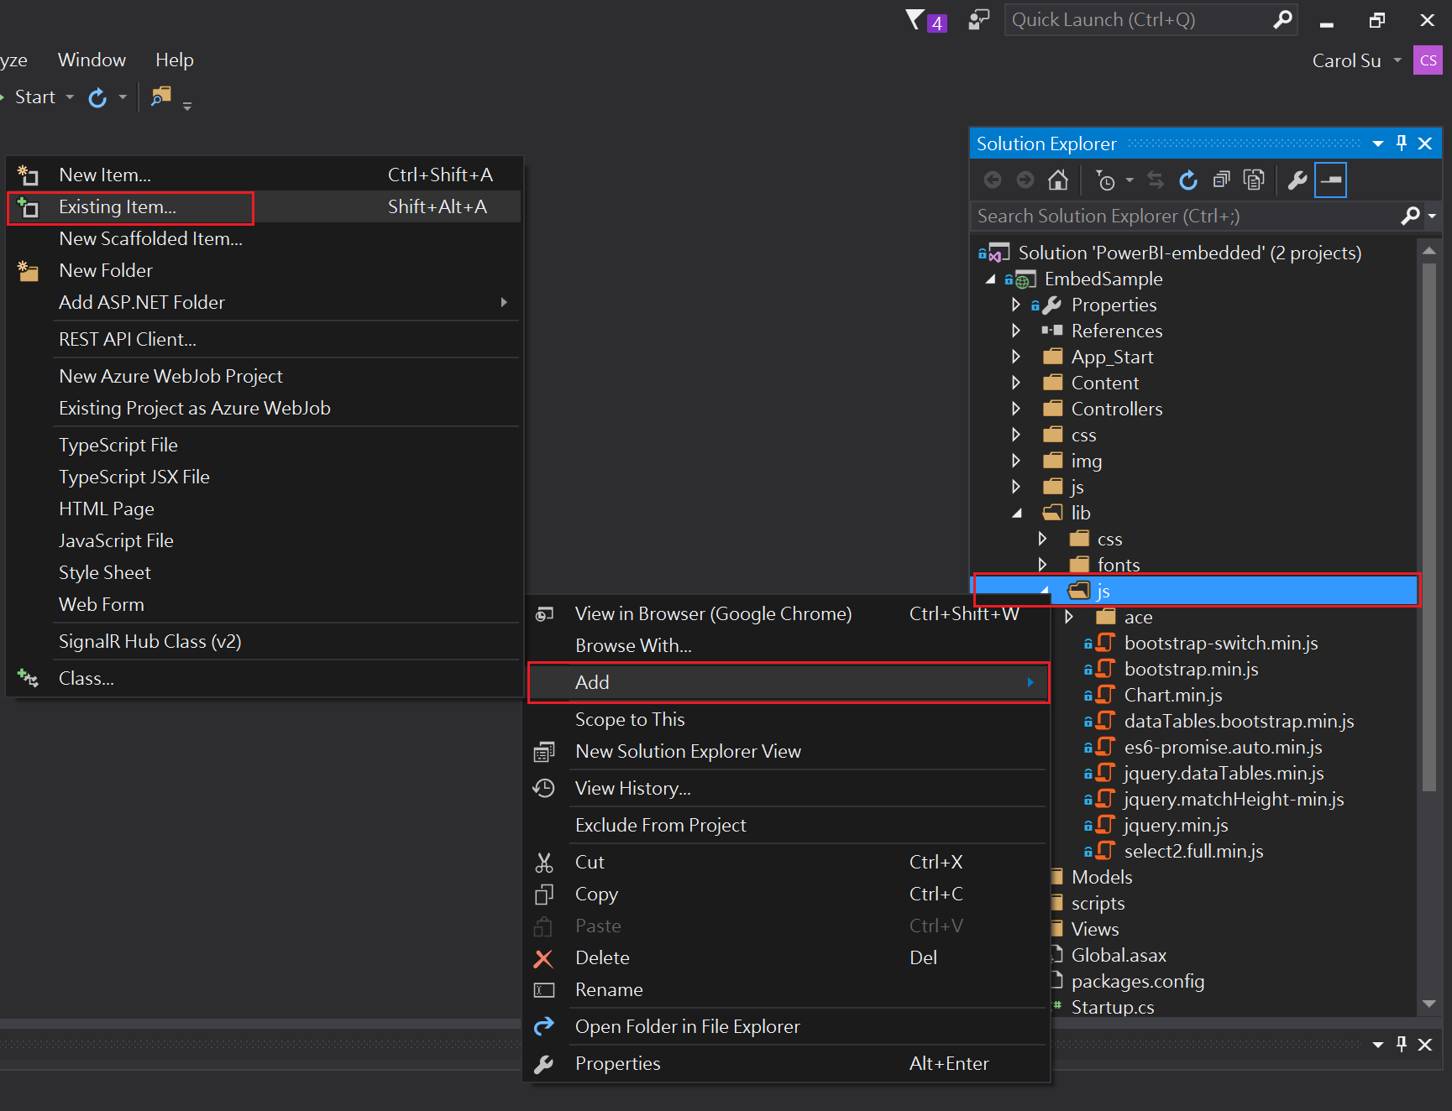

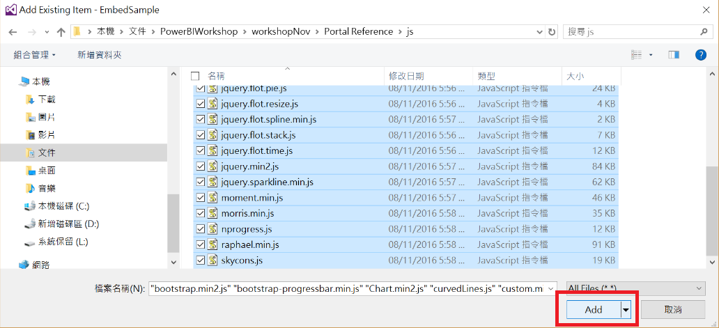

* + - Select **EmbedSample** **>>** **lib >>** **css**
    - Right-click on **css >> Add >>Existing Item**
    - Select all files from **09-HOL**>>**Portal Reference** **>>** **css,** and click **Add**

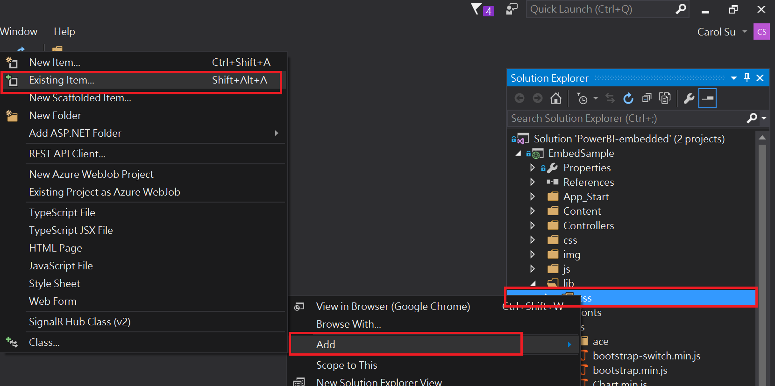

## Step 2: Make portal UI

* Customize dashboard UI for presenting real time data and sending command
  + Select **EmbedSample >> Views >> Dashboards >> Index.cshtml**

& **EmbedSample >> Views >> Dashboards >> Report.cshtml**

* + Right-click the selected files and click **Delete**

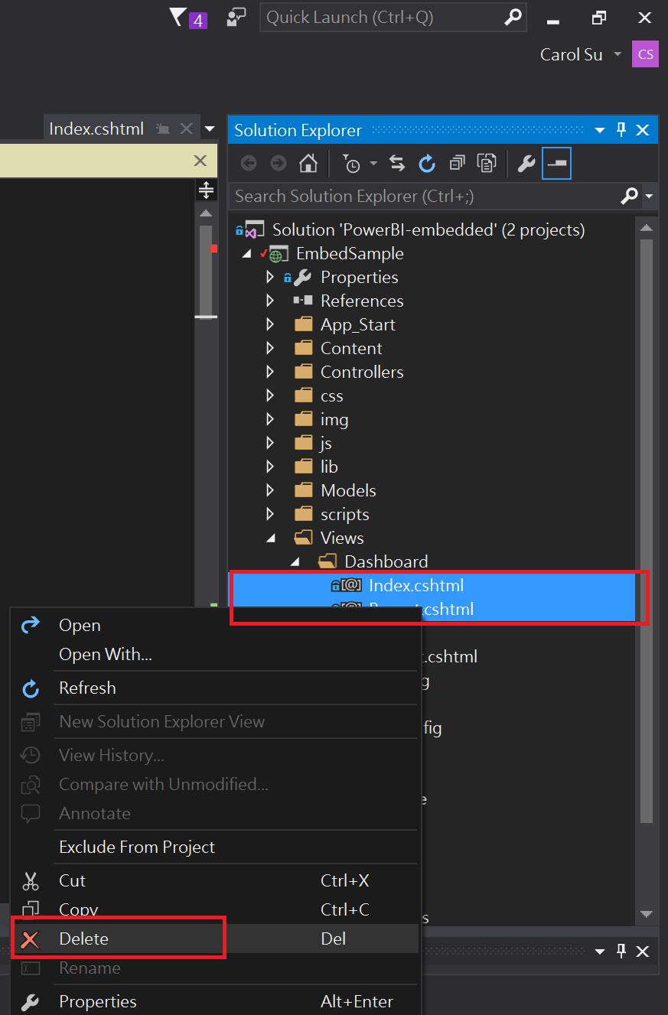

* + Right-click **EmbedSample >> Views >> Dashboards**
  + Select **Add >> Existing Item**
  + Select **09-HOL**>> **Portal Layout** >> **Index.cshtml** &

**09-HOL**>> **Portal Layout** >> **Report.cshtml**

* + Click **Add**

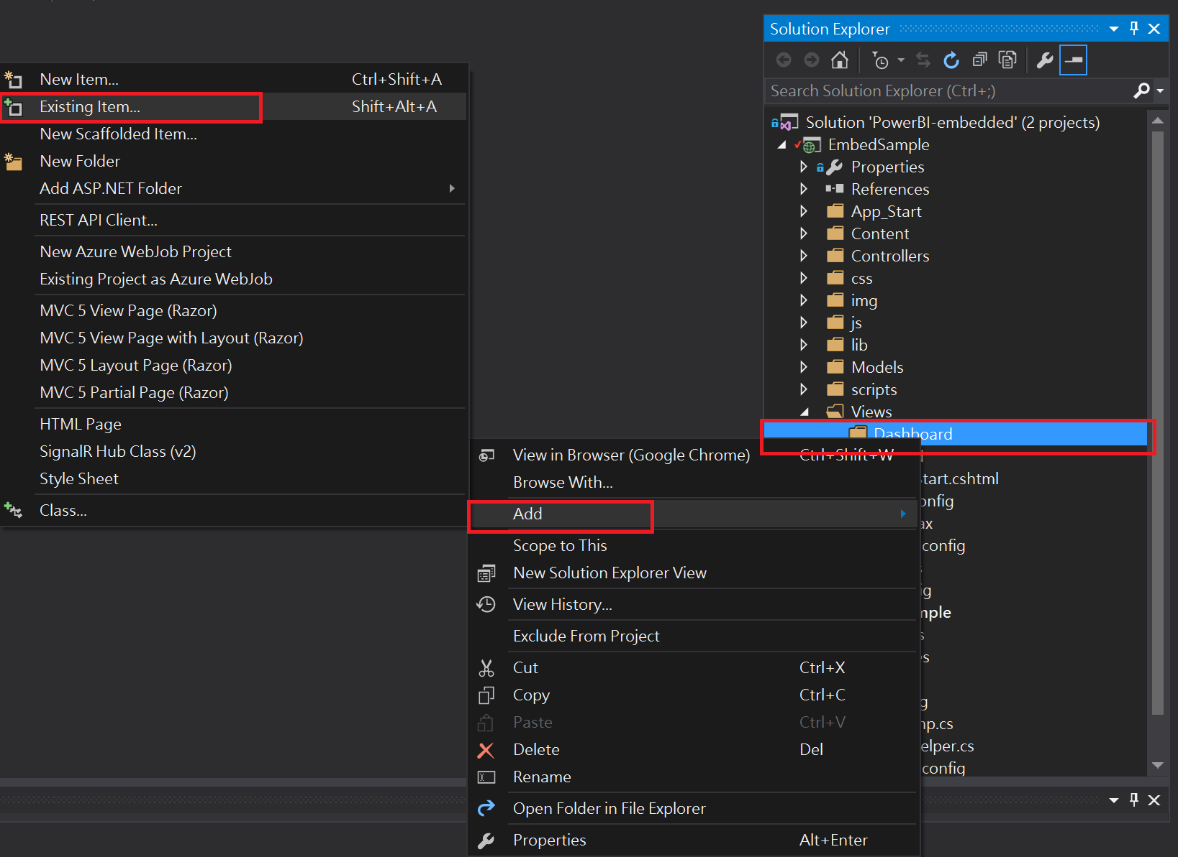

* + Build

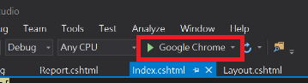

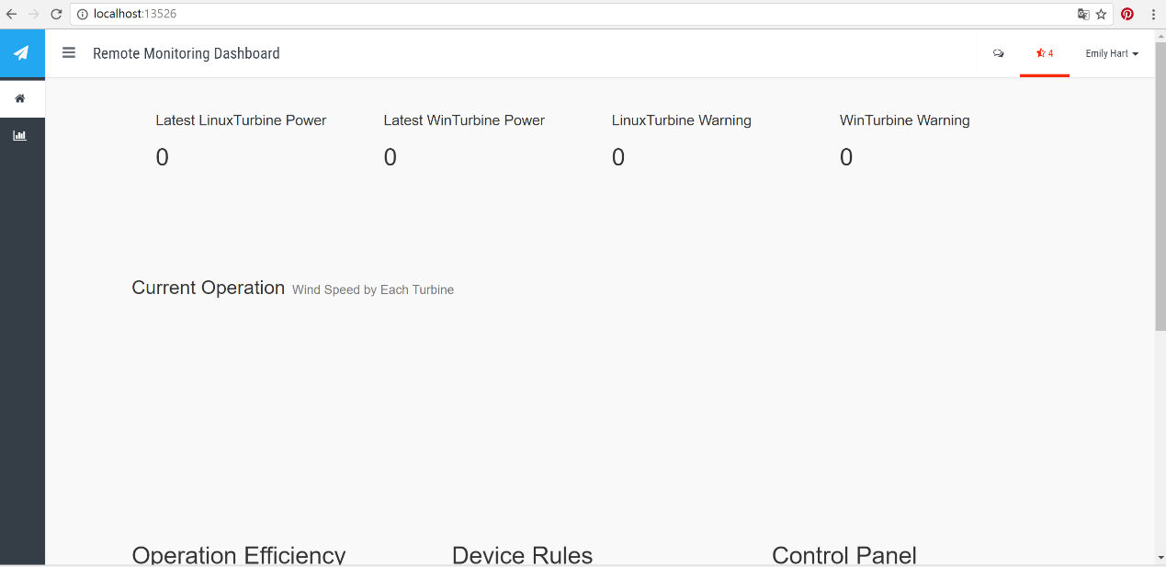

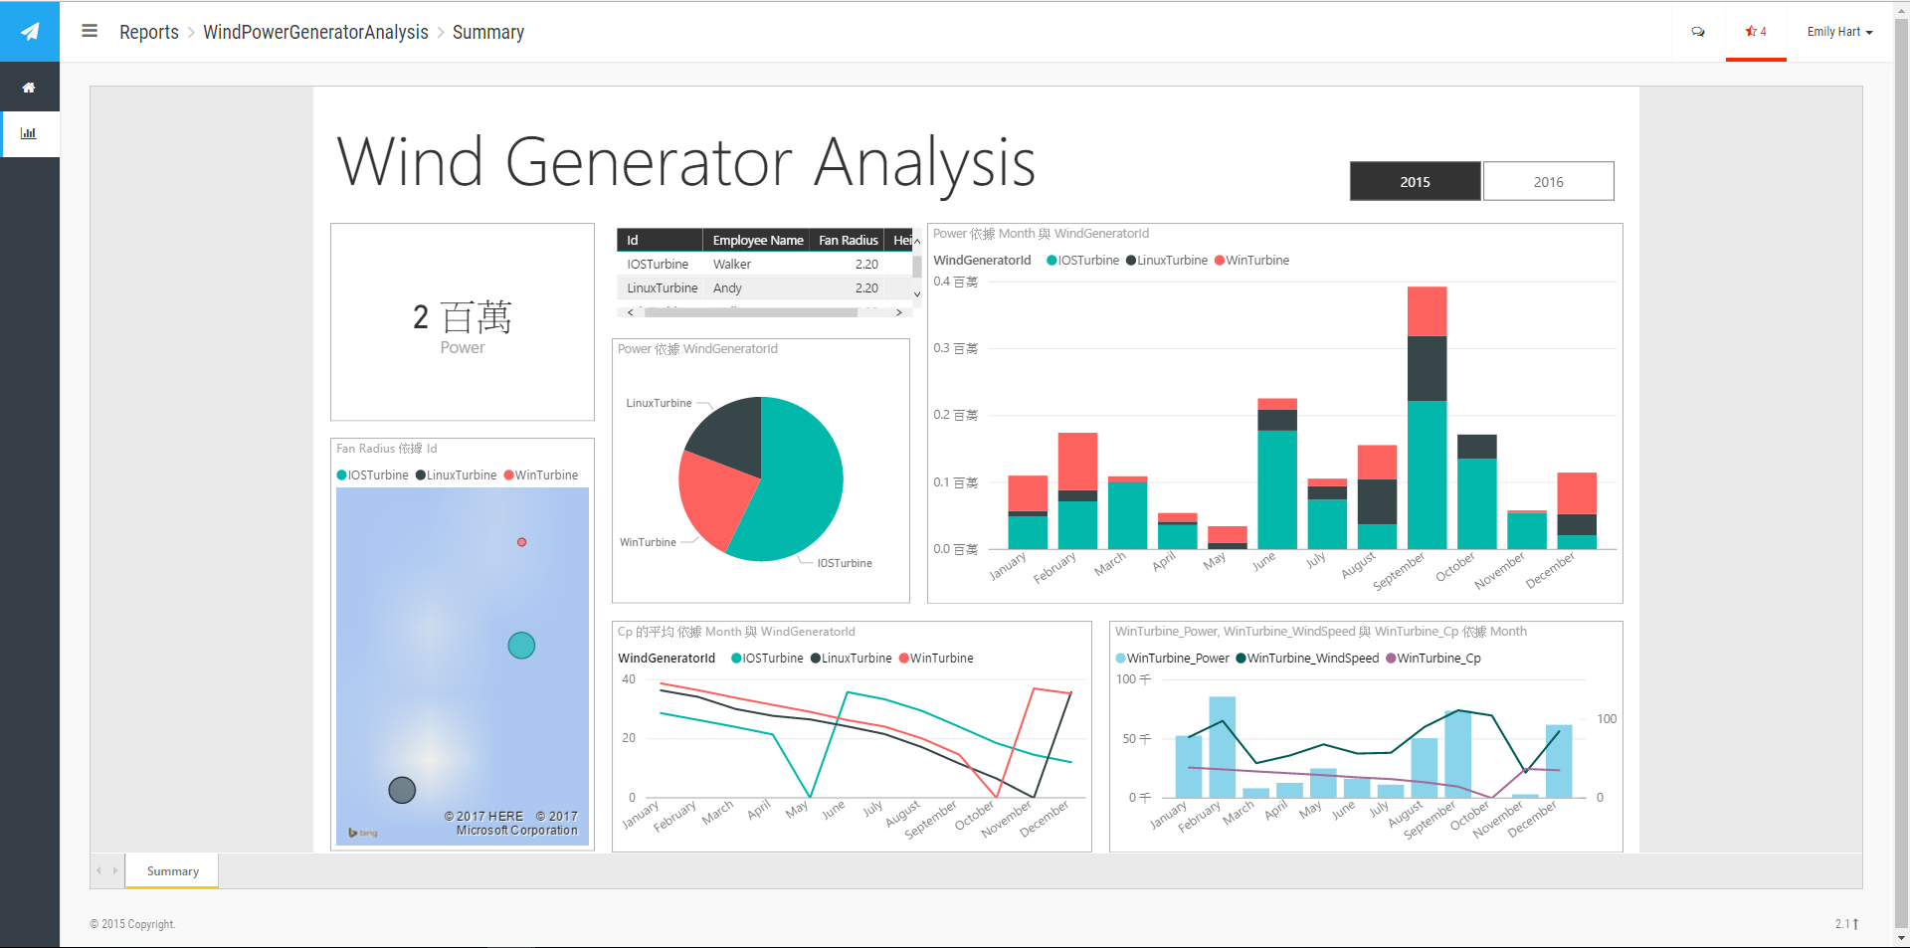

* Add the css and js reference to draw the real time charts
  + Select **EmbedSample >> Views >> Shared >>_Layout.cshtml**
  + Right-click selected files and click **Delete**
  + Right-click **EmbedSample >> Views >> Shared**
  + Select **Add >> Existing Item**
  + Select **09-HOL**>> **Portal Layout** >> _**Layout.cshtml**, click **Add**
  + Build

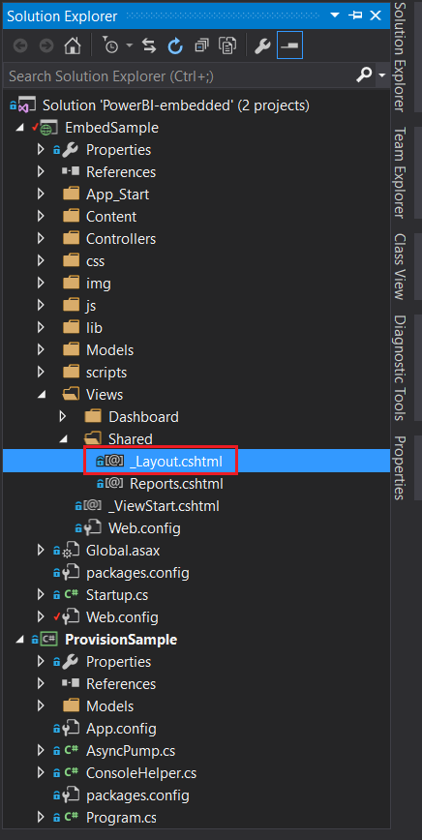

* + Build and Done

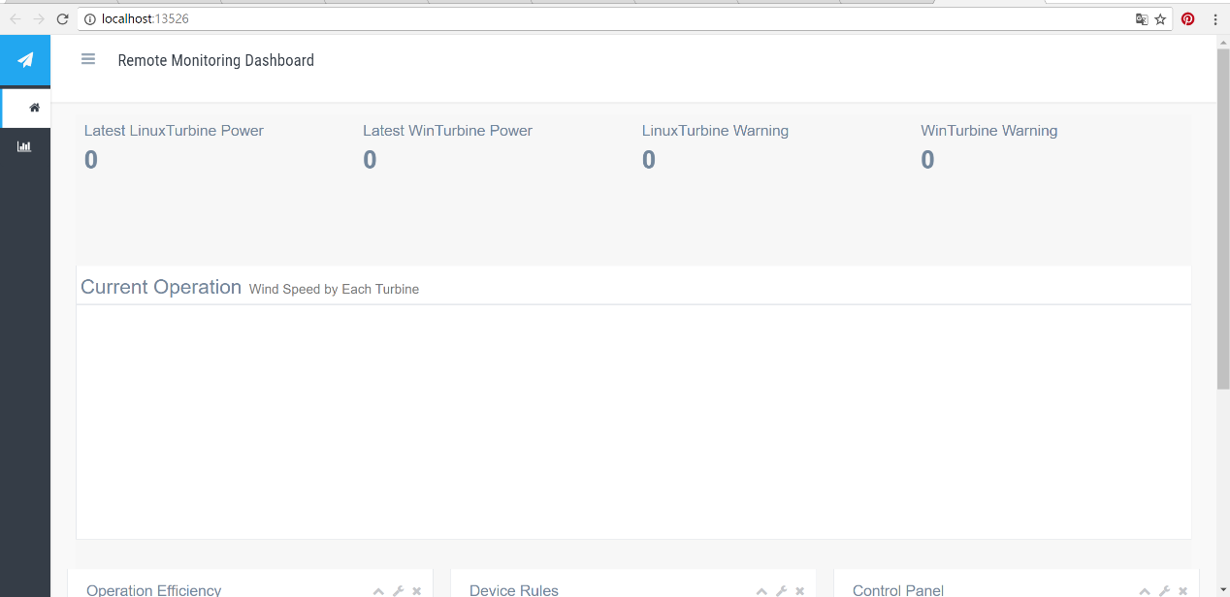

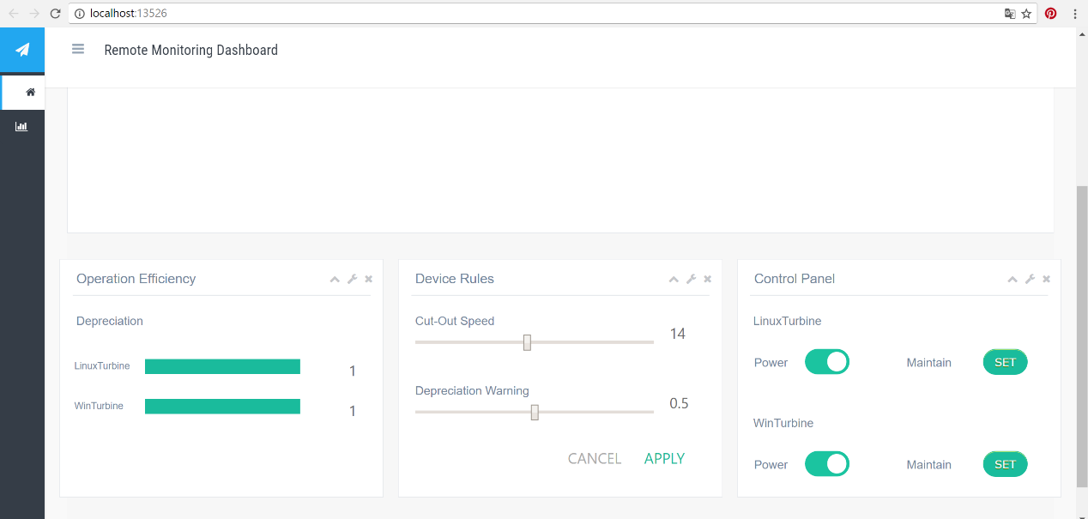

* *The HOL 9 has been completed. Now we finished the UI customization for web portal.*